## Practical task 1

**1. The following bar graph shows the gender wage gap in 26 countries based on data collected by the OECD. The gender wage gap is calculated by finding the difference between male and female median wages and dividing it by male median wages. It is represented as a percentage in this graph.**

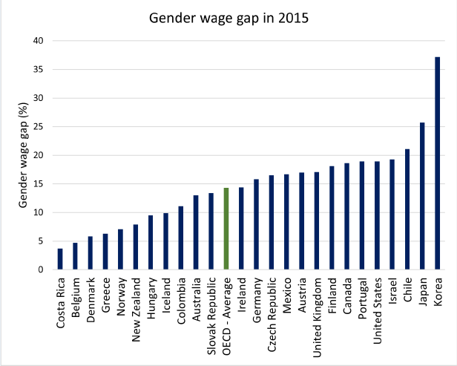

**1a. Which three countries have the lowest gender wage gap?**

The three countries with the lowest gender wage gap are Costa Rica, Belgium and Denmark (ascending order).

**1b. Which three countries have the highest gender wage gap?**

The three countries with the highest gender wage gap are Chile, Japan and Korea (ascending order).

**1c. Do some research on the country with the lowest gender wage gap and comment on why you think they succeeded in achieving a lower gender wage gap in 2015 (max. 150 words).**

In 2015, Costa Rica had one of the lowest gender wage gaps globally, largely due to strong governmental policies promoting education and gender equality. The OECD’s vocational education and training (VET) initiatives significantly improved access to education, especially through the National Learning Institute (INA), which provided skill-based training to individuals aged 15 and above. This allowed women to enter higher-skilled, better-paying jobs, reducing the wage gap(*A Skills beyond School Review of Costa Rica | OECD*, n.d.).

Costa Rica's commitment to promoting gender equality within education and the workplace is also key. Policies encouraging women’s participation in all sectors, including technology and business, helped reduce occupational segregation and enabled women to enter traditionally male-dominated fields, which tend to offer higher wages (*Global Gender Gap Report 2015 | World Economic Forum*, n.d.).

However, challenges persist. Women remain disproportionately represented in low-paying, informal jobs and continue to face higher rates of poverty and unemployment. These women are more likely to depend on social safety nets like non-contributory pensions, which indicate ongoing economic vulnerability (*Global Gender Gap Report 2015 | World Economic Forum*, n.d.). While full wage parity has not been achieved, Costa Rica's educational reforms have played a critical role in narrowing the gap.

**2. The following line graph shows the sale of isopropanol from May 2019 to March 2020 in the United States of America. The sales are measured using US cents per weight (lb) of the product (US CTS/lb). Focus on the general trend of the three lines on the graph rather than what each of the lines refers to specifically when answering the questions.**

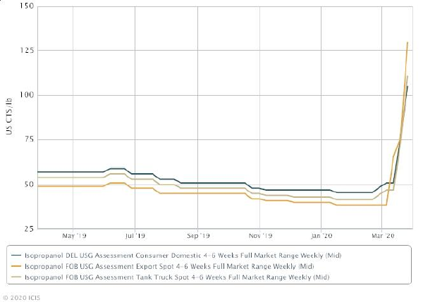

**2a. Explain what is happening in the graph during March 2020 with regards to isopropanol sales (max. 100 words).**

The sales of isopropanol surged dramatically in March 2020 across domestic, industrial, and export markets, increasing by over 100%. Domestic consumption rose from an average of 50 US CTS/lb to 110 US CTS/lb, while export sales spiked from 40 US CTS/lb to 130 US CTS/lb. This sharp increase was unprecedented compared to the previous months.

**2b. Describe a possible reason for the observation you made about isopropanol sales in March 2020 (max. 100 words). Hint: Isopropanol is the main ingredient in hand sanitiser.**

The sharp rise in isopropanol sales in March 2020 was driven by the global COVID-19 pandemic, which dramatically increased demand for hand sanitizers—a product where isopropanol is a key ingredient. As individuals, hospitals, and businesses struggled to secure supplies for hygiene and disinfection, both domestic and international demand soared.

Besides hand sanitizers, isopropanol is also widely used in medical disinfectants and industrial cleaning agents, which likely contributed to the surge.

**3. Below, the bubble plot (a scatter plot with variable dot size) shows carbon dioxide (CO2) emissions per person in tonnes vs the gross domestic product (GDP) per capita (average per person). No unit is given for the GDP per capita; however, the US dollar is typically used when comparing different countries (Callen, n.d.). Each dot represents a country. The colours of the dots refer to the continent to which the country belongs. The size of the dot refers to the size of the population in the country. The larger the dot, the larger the population.**

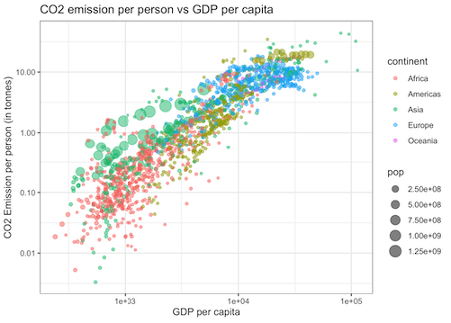

**3a. Discuss the relationship between CO2 emissions per person and GDP per capita for each continent listed in the figure legend (max. 350 words).**

The general trend in the bubble plot shows a positive correlation between CO₂ emissions per person and GDP per capita—wealthier nations tend to have higher emissions due to increased energy consumption, industrialisation, and transportation use. However, significant variations exist across continents:

* **Europe & Americas**: Most industrialised nations in these regions exhibit high GDP per capita and high CO₂ emissions per person, reflecting energy-intensive economies. However, some countries deviate from this trend, with lower emissions than expected for their GDP levels.
* **Asia**: Many rapidly growing economies with large populations show emissions per capita that are higher than expected compared to their GDP per capita. This suggests that factors beyond economic output, such as industrial activity and energy demand, influence emissions. Some high-GDP Asian countries, however, appear to have emissions levels closer to those of Europe.
* **Africa**: Countries in Africa display low CO₂ emissions per person, which corresponds with lower GDP per capita. The distribution suggests that industrial activity and energy use remain limited across the continent compared to other regions.
* **Oceania**: Countries in Oceania show high CO₂ emissions per capita, comparable to those in Europe, despite their smaller populations. This suggests that factors other than population size significantly impact emissions levels in this region.

Thus, while GDP per capita is a major driver of CO₂ emissions per person, other factors, such as population size, industrialisation level, and economic structure, appear to influence the distribution of emissions across different continents.

## Practical task 2

**The following scatterplot matrix is from the Ames Housing dataset. It contains data collected by the Ames City Assessor’s Office describing 2930 property sales which occurred in Ames, Iowa between 2006 and 2010. The data includes the sale price ($), year the house was built, size of the garage (ft2) and size of the living area (ft2).**

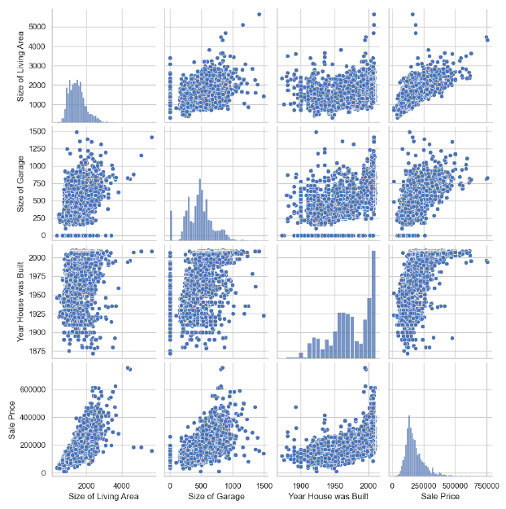

**a) What do the graphs along the diagonal represent?**

The graphs along the diagonal represent histograms for each of the variable in the dataset:

* Size of living area (ft²)
* Size of garage (ft²)
* Year house was built
* Sale price ($)

**b) Are most garages in Ames larger or smaller than 1000 ft2?**

Most garages in Ames are smaller than 1000 ft2, with the average size being around 800 ft2.This can be observed in the histogram for garage size, where the majority of values cluster below 1000 ft².

**c) Are the most expensive houses in Ames built before or after 1950?**

The most expensive houses in Ames were built after 1950, with the highest sale prices typically for houses built after 2000.

**d) Describe the relationship between ‘Size of Living Area’ and ‘Sale Price’.**

There is a strong positive correlation between Size of Living Area and Sale Price—houses with larger living areas tend to sell for higher prices.

However, some outliers exist, where large houses have relatively low prices, likely due to location, market demand, or property conditions.